Biomes
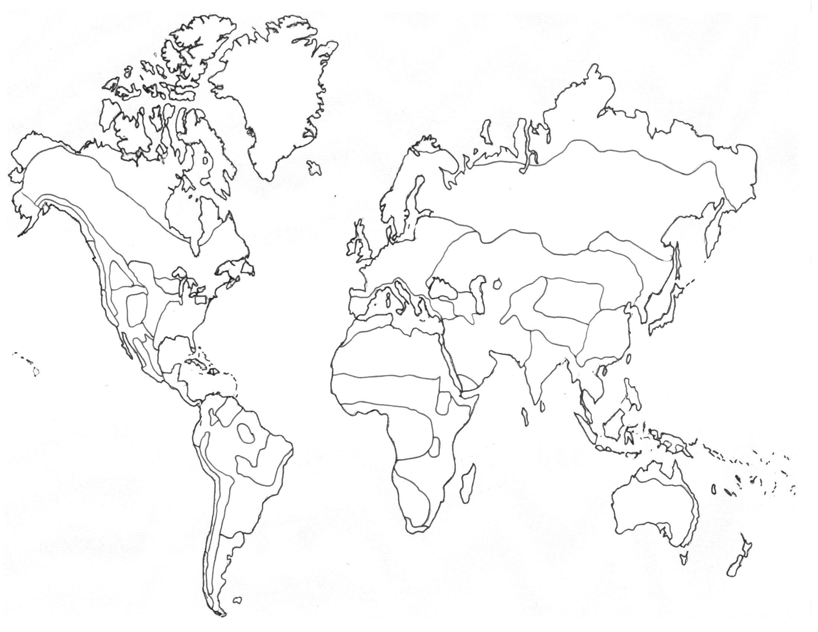
Identify the following Biomes on the map above using a different color for each Biome (indicate the color next to the biome name)
____Temperate Deciduous Forests ____ Savanna ____ Arctic & Antarctic ____ Mangrove
Swamps
____Tropical Rain Forests ____ Chaparral ____ Marshes & Swamps ____ Rocky Shores
____Temperate Rain Forests ____ Deserts ____ Rivers ____ Sandy Shores
____Taiga ____ Tundra ____ Estuaries ____ Oceans
____Temperate Grasslands ____ Lakes & Ponds ____ Salt Marshes ____ Coral Reefs

Table of Contents
Unit 1: Land Biomes
Chapter 1: Forest Biomes
Temperate Deciduous Forests
Tropical Rain Forests
Temperate Rain Forests
Taiga
Chapter 2: Grassland Biomes
Temperate Grasslands
Savanna
Chaparral
Chapter 3: Desert Biomes
Deserts
Tundra
Unit 2: Aquatic Biomes
Chapter 1: Freshwater Ecosystems
Lakes and Ponds
Freshwater Marshes and Swamps
Rivers

Chapter 2: Marine Ecosystems
Coastal Wetlands
Estuaries
Salt Marsh and Mangrove Swamps
Rocky Shores and Sandy Shores
Coral Reefs
Oceans
Arctic and Antarctic

Temperate Deciduous Forest Picture:
Description:
Latitude Range: Location:
Map:
Abiotic Factors Biotic Factors:
Precipitation per year: Plants Animals
Temperature Range: 1. 1.
Light: 2. 2.
Soil 3. 3.
Other 4. 4.
Zones: (description)
1.
2.
3.
Animal Adaptations:

Plant Adaptations:

Organism: picture:
Adaptations to Biome:
Population:
Community:
Ecosystem:

Food Web from Biome:
Human Impacts/effects:

Misc Facts:
Tropical Rainforest Picture:
Description:
Latitude Range: Location:
Map:
Abiotic Factors Biotic Factors:
Precipitation per year: Plants Animals
Temperature Range: 1. 1.
Light: 2. 2.
Soil 3. 3.
Other 4. 4.
Layers: (description)
1.
2.
3.
Animal Adaptations:

Plant Adaptations:

Organism: picture
Adaptations to Biome:
Population:
Community:
Ecosystem:
Food Web from Biome:

Human Impacts/effects:

Misc Facts:
Temperate Rainforest Picture:
Description:
Latitude Range: Location:
Map:
Abiotic Factors Biotic Factors:
Precipitation per year: Plants Animals
Temperature Range: 1. 1.
Light: 2. 2.
Soil 3. 3.
Other 4. 4.

Animal Adaptations:

Plant Adaptations:

Organism: picture
Adaptations to Biome:

Population:

Community:
Ecosystem:

Food Web:

Human Impacts/effects:

Misc Facts:
Taiga Picture:
Description:
Latitude Range: Location:
Map:
Abiotic Factors Biotic Factors:
Precipitation per year: Plants Animals
Temperature Range: 1. 1.
Light: 2. 2.
Soil 3. 3.
Other 4. 4.
Animal Adaptations:

Migratory animals:

Year-round residents:

Plant Adaptations:

Adaptations:

Conifer trees:
Organism: picture
Organism’s adaptations to Biome:
Population:
Community:
Ecosystem:
Food Web from Biome:
Human Impacts/effects:
Misc Facts:
Savannas Picture:
Description:
Latitude Range: Location:
Map:
Abiotic Factors Biotic Factors:
Precipitation per year: Plants Animals
Temperature Range: 1. 1.
Light: 2. 2.
Soil 3. 3.
Other 4. 4.

Animals:

Adaptations:

Plants:
Fires effect on Biome:

Organism: picture
Organism’s adaptations to Biome:
Population:
Community:
Ecosystem:
Food Web from Biome:

Human Impacts/effects:
Misc Facts:
Temperate Grasslands Picture:
Description:
Latitude Range: Location:
Map:
Abiotic Factors Biotic Factors:
Precipitation per year: Plants Animals
Temperature Range: 1. 1.
Light: 2. 2.
Soil 3. 3.
Other 4. 4.

Animals:
Adaptations:

Plants:
Adaptations:

Prairie grasses:
Wild flowers:
Organism: picture
Organism’s adaptations to Biome:
Population:
Community:
Ecosystem:
Food Web from Biome:

Human Impacts/effects:
Misc Facts:
Chaparral Picture:
Description:
Latitude Range: Location:
Map:
Abiotic Factors Biotic Factors:
Precipitation per year: Plants Animals
Temperature Range: 1. 1.
Light: 2. 2.
Soil 3. 3.
Other 4. 4.

Animals:
Adaptations:

Plants:
Adaptations:

Fires effect on Biome:

Organism: picture
Organism’s adaptations to Biome:
Population:
Community:
Ecosystem:
Food Web from Biome:

Human Impacts/effects:
Misc Facts:
Deserts Picture:
Description: Location:
Latitude Range: Hot Deserts:
Map: Cold Deserts:
Abiotic Factors Biotic Factors:
Precipitation per year: Plants Animals
Temperature Range: 1. 1.
Light: 2. 2.
Soil 3. 3.
Other 4. 4.

Animals:
Adaptations:

Plants:
Adaptations:

Succulents:
Organism: picture
Organism’s adaptations to Biome:
Population:
Community:
Ecosystem:
Food Web from Biome:

Human Impacts/effects:
Misc Facts:
Tundra Picture:
Description: Location:
Latitude Range: Permafrost:
Map:
Abiotic Factors Biotic Factors:
Precipitation per year: Plants Animals
Temperature Range: 1. 1.
Light: 2. 2.
Soil 3. 3.
Other 4. 4.
Animal Adaptations:

Plant Adaptations:

Bogs and swamps: formation and importance:

Migratory Birds:

Organism: picture
Organism’s adaptations to Biome:
Population:
Community:
Ecosystem:
Food Web from Biome:

Human Impacts/effects:
Misc Facts:
Lakes and Ponds Picture:
Description:
Zones:
a.
b.

Abiotic Factors Biotic Factors:
Plants Animals
1. 1.
2. 2.
Animal Adaptations:

Plant Adaptations:

Eutrophication:

Environmental Functions of Wetlands:

Organism: picture
Organism’s adaptations to Biome:
Population:
Community:
Ecosystem:
Food Web from Biome:

Human Impacts/effects:
Misc Facts:
Freshwater Marshes and Swamps:
Location: Map:
Zones:
a.
b.

Abiotic Factors Biotic Factors:
Plants Animals
1. 1.
2. 2.
Freshwater Marsh Description: Freshwater Swamp Description:
Picture: Picture:
Plants: Plants:

Plant Adaptations: Plant Adaptations:

Animals: Animals:

Adaptations: Adaptations:

Organism: picture Organism: picture

Organism’s adaptations to Biome: Organisms adaptations to Biome:

Population: Population:
Community: Community:
Ecosystem: Ecosystem:
Food Web from Marsh: Food Web for Swamps:

Human Impacts/effects: Human Impacts/Effects
Misc Facts: Misc Facts:
Rivers Picture:
Formation:

Abiotic Factors Biotic Factors:

Headwaters:
Animals and Adaptations:

Plants and Adaptations:

Wide Channels Downstream:
Animals and Adaptations:

Plants and Adaptations:

Organism: picture
Organism’s adaptations to Biome:
Population:
Community:
Ecosystem:
Food Web from Biome:

Dangers to Rivers:
1.
2.
3.
4.
Misc Facts:

Estuaries Picture:
Definition/Description:

Nutrients in estuaries:

Function of estuaries:
1.
2.

Abiotic Factors Biotic Factors:

Plants:
Adaptations:
Animals:
Adaptations:
Organism: picture
Organism’s adaptations to Biome:
Population:
Community:
Ecosystem:

Food Web from Biome:
Threats to Estuaries:
1.
2.
3.
4.

Misc Facts:
Salt Marshes Mangrove Swamps
Picture: Picture:
Description: Description:

Formation: Formation:
Location: Location:
Abiotic Factors Biotic Factors:
Latitude Range:
Temperature:
Nutrients:
Salt Marsh Description: Mangrove Swamp Description:
Picture: Picture:
Plants: Plants:

Plant Adaptations: Plant Adaptations:

Animals: Animals:

Adaptations: Adaptations:

Organism: picture Organism: picture

Organism’s adaptations to Biome: Organisms adaptations to Biome:
Population: Population:
Community: Community:
Ecosystem: Ecosystem:
Food Web from Marsh: Food Web for Swamps:
Threats to Salt Marshes and Mangrove Swamps:
1.
2.
Misc Facts:
Rocky Shores Sandy Shores
Picture: Picture:
Description: Description:
Formation: Formation:
Location: Location:
Abiotic Factors Biotic Factors:
Latitude Range:
Temperature:
Rocky Shore Description: Sandy Shore Description:
Picture: Picture:
Plants: Plants:

Plant Adaptations: Plant Adaptations:

Animals: Animals:

Adaptations: Adaptations:

Organism: picture Organism: picture
Organism’s adaptations to Biome: Organisms adaptations to Biome:
Population: Population:
Community: Community:
Ecosystem: Ecosystem:
Food Web from Rocky Shore: Food Web from Sandy Shore:
Human Impacts/effects: Human Impacts/Effects
Misc Facts: Misc Facts:
Threats to Rocky and Sandy Shores:
1.
2.

Misc Facts:
Coral Reefs Picture:
Definition/Description:

Formation of coral Reefs:

Latitude Range:

Abiotic Factors Biotic Factors:
Water temp:
Sunlight:

Plants:
Adaptations:
Animals:
Adaptations:
Organism: picture
Organism’s adaptations to Biome:
Population:
Community:
Ecosystem:

Food Web from Biome:
Threats to Coral Reefs:
- coral bleaching

2.

3.

Misc Facts:
Oceans Picture:
Definition/Description:
Name Oceans:

Abiotic Factors Biotic Factors:
Water temp:
Sunlight:

Plants:
Adaptations:
Animals:
Adaptations:
Organism: picture
Organism’s adaptations to Biome:
Population:
Community:
Ecosystem:

Food Web from Biome:
Threats to Oceans:
1.
2.
3.

Misc Facts:
Arctic and Antarctic Picture:
Definition/Description:
Latitude Range:
Location/Map:

Abiotic Factors Biotic Factors:
Water temp:
Sunlight:
Nutrients from
Arctic Antarctic
Plants: Plants:
Adaptations: Adaptations:
Animals: Animals:

Adaptations: Adaptations:

Organism: picture Organism: picture
Population: Population:
Community: Community:
Ecosystem: Ecosystem:
Food Web from Biome: Food Web from Biome:

Threats to Arctic and Antarctic:

Misc Facts:

