Booklet: Survivor How to Guide (50 points)

3 Days out in a Biome. How do you survive?
Include in your booklet: (5 points each)
- Pick a specific place in a Biome (include a map)
- Your source of food and water
- Pick a time of year (season)
- Describe local weather
- Clothing needed (day & night)
- Sleeping – where, in what
- Protection from predators
- Dangers – plants, animals, insects
- List 5 daily activities
- Creativity, use of booklet form

Brochure: Sustainable Product (50 points)
Create an informational brochure on a sustainable product from a specific biome to be used by a sales person trying to sell the product
Include in your brochure: (5 points each)
- Describe/ indentify product
- Picture of product
- Where is product found (map)
- What other resources needed to create your product
- How is it collected, removed
- Impact of collection/removal on ecosystem
- What makes it sustainable/green
- What not sustainable product does it replace
- Cost of sustainable product vs. non sustainable product
- Effect on indigenous people

Information/Protest Poster: Exotic Animal or Animal Parts Protest Poster (50 points)
Create a poster on one side identify some type of animal resale or poaching in a specific biome and on the other side create a protest sign to be held up at a rally
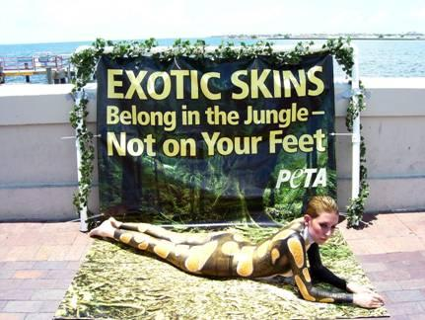
Include in your brochure: (5 points each)
- Describe/ indentify the animal/animal product
- Picture of the animal
- Map of where the animal lives
- Description of why they are being poached/captures
- Describe the capture method (picture)
- Cost of product
- Whose buying product
- Describe efforts in prevention or measures to control the poaching/capture
- What are the penalties if caught
- Protest catchy phrase

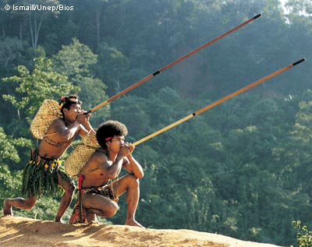

Interview Script: Indigenous People Interview
After researching your biome and an indigenous people in that biome, create a script of how you think they would answer your questions regarding their life in their biome.
Include in your brochure: (5 points each)
- Describe where the person lives
- Picture of what the people look like
- How do they “make their living” (they don’t have to go to work to make a living)
- What do they do for recreation
- What do they live in
- What are their daily activities
- What are 2 threats to their way of life (10 points)
- What are the changes (list 5) in the people in the past 50 years (10 points)
Children’s Book: Climate Change Fairy Tale (50 points)
Create a Fairy Tale on Climate Change in a specific Biome
Describe the Biome Now (what’s the problem), Identify a hero or heroine and how they are going to rectify the problem, is the rectification successful or not, describe what the biome looks like after the rectification
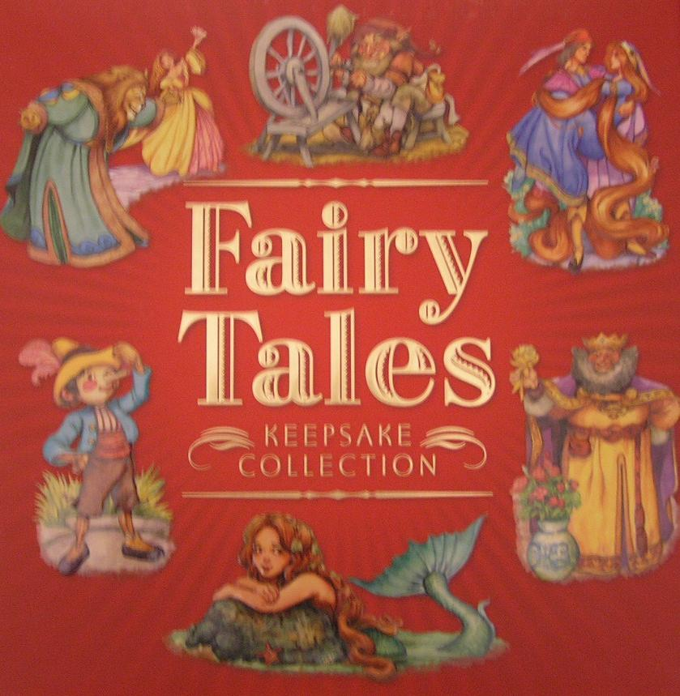
Include in your brochure: (10 points each)
- Describe the problem and what it has done to the biome
- How is the problem rectified
- Is it successful or not and why
- Illustrations, title cover, creativity
- Written well (grammatically correct)

Video: Newscast Interview or Report (50 points, 5 points each)
Research a current event in a specific Biome and create an interview or report
Include the following:
- Identify a current event in a specific biome
- Report on location
- Describe the problem
- Effect of the problem on the people of the area, their health or wellbeing
- What’s the effect on the economy
- Effect on organisms (plants and animals)
- What’s being done to stop/prevent the problem
- Who are the stakeholders
- Is the solution to the problem effective or not
- What are the barriers to the success of the solution

Biomes Board game (60 points, 50 points plus 10 points extra credit)
Create a biomes board game
Include the following (10 points each)
- Include all biomes (land and aquatic)
- Include characteristics of all biomes
- Include all current problems (examples: human impacts, biodiversity, pollution< climate change, etc…)
- Create a complete board game (game board, pieces, questions cards, pieces, etc.)
- Must be colorful, creative
- Must have specific written rules (Must have a winner, must be played in class)

