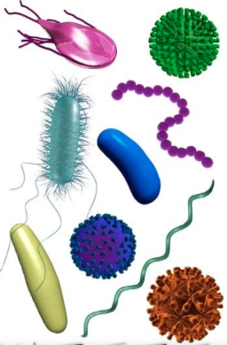
Design a class presentation on a Food borne infection

Each student/pair will be required to design a large poster with pictures and information on the Foodborne illness.

A video must be found to show the class as an intro to their presentation.

Groups must include

Disease and Organism That Causes It: Genus and Species

Most frequent food sources

Onset and General symptoms

Prevention methods

