Understanding the food pyramid:
You should center your diet around the foods at the base of the food pyramid, and eat less of the foods at the top. If you're watching your weight then you should concentrate on eating the minimum number of recommended daily servings. If you are looking to gain extra weight, eat the maximum number of servings.
You may also be interested in seeing how many calories you burn during certain activities How to Count and Calculate Calories

Picture of the old food pyramid
Old food pyramid picture | How much is one serving?  Milk products group:  1 cup about 8 oz. of milk or yogurt  2 slices of cheese, 1/8" thick (1 1/2 oz.)  2 cups of cottage cheese  1 1/2 cups of ice milk, ice cream or frozen yogurt  Meat group:  2 oz. to 3 oz. of cooked lean meat, poultry, fish  2 eggs  7 oz. tofu  1 cup cooked legumes or dried beans or peas  4 tablespoons peanut butter  1/2 cup nuts or seeds  Vegetables:  1/2 cup cooked vegetables  1/2 cup raw chopped vegetables  1 cup raw leafy vegetables  1/2 to 3/4 cup vegetable juice  Fruits:  1 whole medium fruit (about 1 cup)  1/4 cup dried fruit  1/2 cup canned fruit  1/2 to 3/4 cup fruit juice  Bread and Cereals:  1 slice bread  1 medium muffin  1/2 hot dog bun or hamburger bun  1/2 bagel or english muffin  4 small crackers  1 tortilla  1 cup cold cereal  1/2 cup cooked cereal  1/2 cup rice  1/2 cup pasta

How many servings of each per day should you eat?
Foods | Women - Children - Elderly | Teenage girls - Active Females - Males | Teenage boys - Active Males
Calorie level | Aprox. 1,600 | Aprox. 2,200 | Aprox. 2,800
MILK Group Products | 2 to 4 | 2 to 4 | 2 to 4
MEAT Group | 2 | 2 | 3
VEGETABLE Group | 3 | 4 | 5
FRUIT Group | 2 | 3 | 4
BREAD and Cereals | 6 | 9 | 11
Total Fat in grams | 36 to 53 | 49 to 73 | 62 to 93
How do I Possibly Eat all those Fruits and Vegetables?
Picture of the new food pyramid
The New Food Pyramid is a tool to educate people to eat a more balanced diet from a greater variety of food portions without counting calories. The USDA has now expanded the four food groups to six groups and expanded the number of servings to meet the calorie needs of most people.
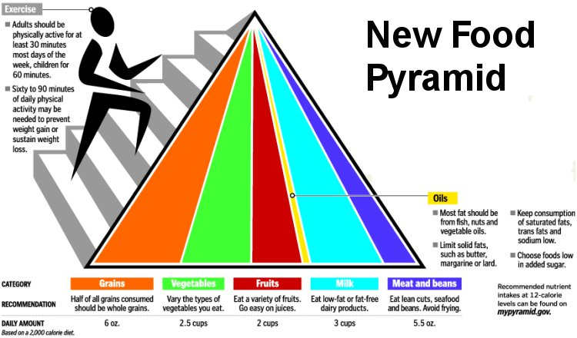
New Food Pyramid
The new food pyramid is more flexible and accurate than the one we had a few years ago. The reason being that one image of a pyramid with markings of what your daily intake should be can not apply to everyone. It all depends on a person's lifestyle and how much exercise they get involved in during a week. It also depends on if a person is trying to lose weight or gain weight. If a person is trying to gain weight then they should proceed to having the highest amounts of recommended servings, if a person is trying to lose weight then they should try to aim for the lowest recommended servings per day. To have a good idea of what you should be eating and how much of it you should be eating. You can view this interactive guide which was made by the United States Department of Agriculture at www.choosemyplate.gov
Disabled World - Disability News and Information: http://www.disabled-world.com/artman/publish/food_pyramid.shtml#ixzz2QjMxilwF

