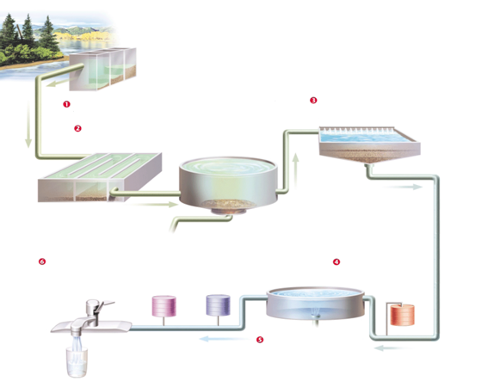

Water Treatment Diagram

Label the 6 steps in the residential water treatment process